 | Lesson 1:Introduction to Java
Q. 1 | Define :  - Bytecode verifier  - Class loader  - JIT compiler  - JVM  - JDK
Ans : | - Component of the JVM that ensures that byte code does not access private data  - Responsible for keeping classes from different servers separate from each other as well as the local classes  - JIT compiler: It is enabled by default and is activated when a java method is called .JIT compiler compiles the byte the code of that method into native machine code compiling it "just in time" to run. When a method has been compiled JVM calls the compile code of that method directly instead of interpreting it.  - Java Virtual Machine where the byte code is executed.  - Java Development Kit, it is a super set consisting of java compiler, JRE, JVM.
 | Lesson 3: Language Fundamentals
Q. 2 | What is the default value for float , char ,byte data types ?  Or  What is the default value of all instance variables
Ans : | int = 0  String = null  float = 0.0f  double = 0.0  boolean=false  Char : a blank space  Any Reference type = null
Q. 3 | a) What happens when you ignore break in switch. Given an Example.  b) Discuss the valid data types that w.r.t switch case ?
Ans : | - All the following cases will get executed till it finds the break statement.  Example :  public class SwitchExample {  public static void main(String[] args) {  // TODO Auto-generated method stub  int i = 0;  switch (i) {  case 0:  System.out.println("i is 0");  case 1:  System.out.println("i is 1");  case 2:  System.out.println("i is 2");  default:  System.out.println("Free flowing switch example!");  }  }  }  Output  i is 0  i is 1  i is 2  Free flowing switch example!  - Switch statement in java works with the following datatypes:  - Primitive datatypes: Byte, Short, Char, Int  - Enumerated datatypes (java enums)  - string class  - few classes that wrap primitive types: Character, Byte, Short, Integer
 | Lesson 4: Classes and Objects
Q. 4 | What will happen if you don’t initialize a local variable and try to print it?
Ans. | Local variable does not have a default value. Unless a local variable has been assigned a value the compiler will refuse to compile the code that reads it.
Q. 5 | What is the need of :  - Final  - Finalize  - Finally
Ans. | - Final: Final is used to apply restrictions on class, method, variable. It is a keyword.  - Finalize: It is used to perform clean up processing just before object is garbage collected. It is a method  - Finally: Finally is used to place important code. It will be executed whether exception is handled or not. It is a block.
Q. 6 | Discuss Static method.
Normally we cannot call a method of a class without first creating an instance of that class.
By declaring a method using the static keyword, you can call it without first creating an object because it becomes a class method.
- If you apply static keyword with any method, it is known as static method.
- A static method belongs to the class rather than object of a class.
- A static method can be invoked without the need for creating an instance of a class.
- static method can access static data member and can change the value of it.
Q. 7 | What is created in heap
Ans | Object
 | Lesson 5: Exploring Basic Java Class Libraries
Q.8 | What are wrapper classes, list all the wrapper classes
Ans | A wrapper class is a class whose object wraps or contain a primitive data types. When we create an object to a wrapper class, it contains a field and in this field, we can store a primitive data types.  Wrapper classes:  1.Character  2.Byte  3.Short  4.Integer  5.Float  6.Double  7.Boolean
Q. 9 | What are the possible modifiers for :  - class/static variables  - instance variables  - local variables
Ans | Possible modifiers for:  a) class/static variables-public, private, static  b) instance variables-public, private, default  c) local variables-final
Q. 10 | Which type of variables must be initialized-mandatory ?
Ans | Local variable must be initialized and it is mandatory.
Q. 11 | Which of the following are mutable/immutable ?  - string  - String buffer  - String builder
Ans. | - String – immutable & synchronized. The object created as String is stored in the Constant String Pool  - String buffer – mutable & synchronized. The object created through StringBuffer is stored in the heap  - String builder – mutable & unsynchronized. Therefore, Thus StringBuilder is faster than the StringBuffer when calling the same methods of each class.
Q. 12 | Give examples of using :  - Append  - Concat  - Equals  - ==  - compareTo
Ans | - Append  StringBuffer sb = new StringBuffer("abc");  sb.append("def");  System.out.println("sb = " + sb); // output is "sb = abcdef"  - Concat :  String str = "Core ";  System.out.println( str=str.concat(" Java") );  Output -> "Core Java”  - d) e) Equals, == , compareTo  String str = "Hello";  String str1 = new String("Hello");  System.out.println(str.equals(str1)); //output : True  System.out.println(str == str1); //output : False  System.out.println( str.compareTo(str1) ); //output : 0
Q. 13 | - Give example of using Scanner object.  - State all the nextxxx() methods used with scanner object
Ans | - Example :  String myInput = null;  Scanner myscan = new Scanner(System.in).useDelimiter("\\n");  System.out.println("Enter your input: ");  myInput = myscan.next();  System.out.println(myInput);  This will let you use Enter as a delimiter.  input: Hello world (ENTER)  output : Hello World  b)  String next()  Boolean nextBoolean()  byte nextByte()  double nextDouble()  float nextFloat()  int nextInt()  String nextLine()  Long nextLong()  Short nextShort()
Q. 14 | Give examples for each :  - Get current date  - Get tomorrows date - Add one day  - Get yesterdays date -Subtract one day
Ans | - LocalDate now = LocalDate.now();  or  - SOP(“Today : “ + now);  - SOP(“Tomorrow : “ + now.plusDays(1));  - SOP(“Yesterday : “ + now.minusDays(1));
Q. 15 | State all Object class methods.
Ans | - clone() - Creates and returns a copy of this object.  - equals() - Indicates whether some other object is "equal to" this one.  - finalize() - Called by the garbage collector on an object when garbage collection determines that there are no more references to the object.  - getClass() - Returns the runtime class of an object.  - hashCode() - Returns a hash code value for the object.  - notify() - Wakes up a single thread that is waiting on this object's monitor.  - notifyAll() - Wakes up all threads that are waiting on this object's monitor.  - toString() - Returns a string representation of the object.  - wait() - Causes current thread to wait until another thread invokes the notify() method or the notifyAll() method for this object.
Q. 16 | Discuss all Access Modifiers
Ans : | 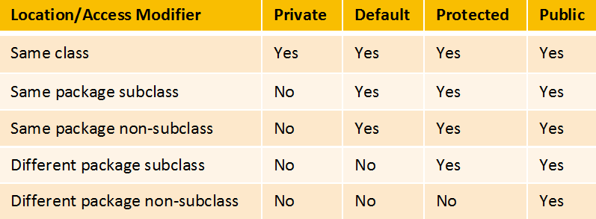
 | Lesson 6: Inheritance and Polymorphism
Q. 17 | Difference between overriding and overloading
Ans | 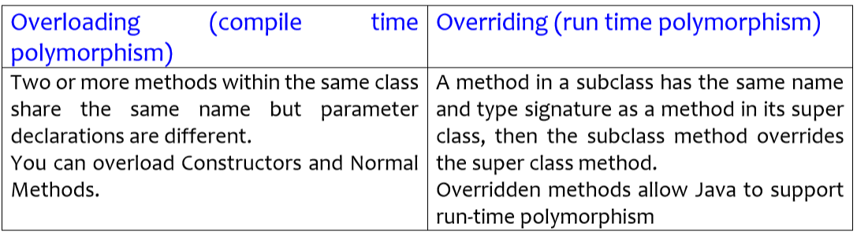  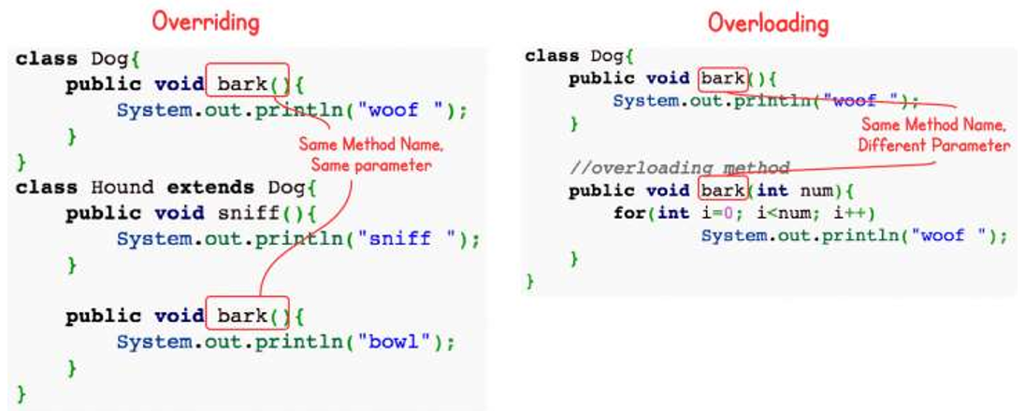
Q. 18 | Difference between Abstract Class and Interface
Ans | 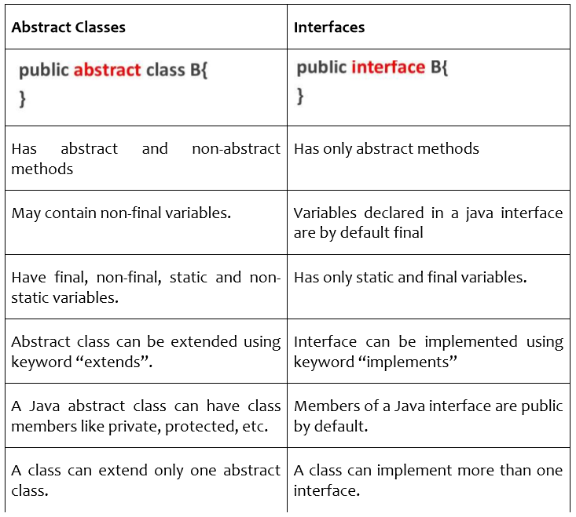
Q. 19 | State the modifiers of the data members in an interface
Ans | Members of an INTERFERENCE are by default PUBLIC.
Q. 20 | Aggregation relationship – how will you implement in java
Ans. | class Employee{  int id;  String name;  Address address;//Address is a class  ...  }
Q. 21 | InstanceOf – Use and Example
Ans | 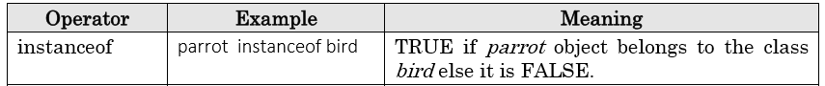  Example :  class Simple1{  public static void main(String args[]){  Simple1 s=new Simple1();  System.out.println(s instanceof Simple1);  }  }  Output : true
Q. 22 | Discuss all points about key word “this” and “super” with examples (while writing constructors)
Ans | THIS  The ‘this’ keyword is used to refer the current object. As shown in the above example, the constructor parameters are shadowing the instance variables. Therefore we can use this keyword to make difference between the local variables/parameters and instance variables.  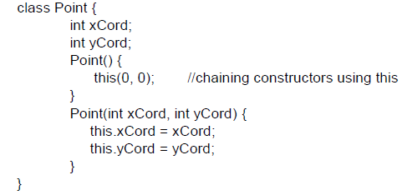  SUPER  It is a reference variable used to refer the immediate parent class  object  - super() invokes immediate parent class constructor  - Call member (variables & methods) of parent class  Syntax : super.baseclassMemberName  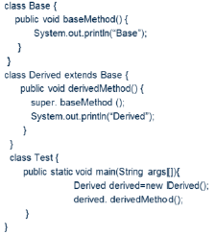
Q. 23 | How will you write varargs (what conditions must be followed).
Ans | 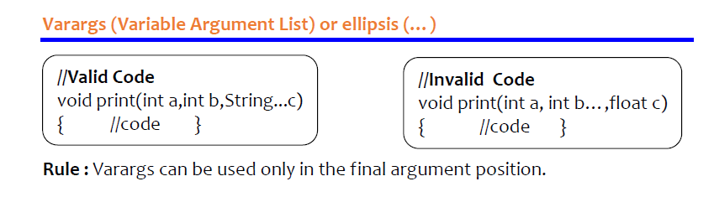
Q. 24 | Explain all points about :  - Final variable  - Final method  - Final class
Ans | 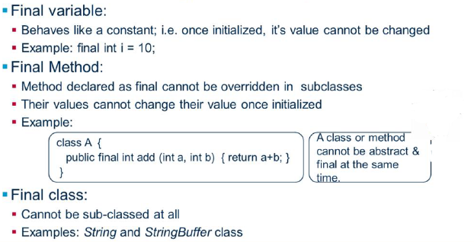
 | Lesson 7: Abstract Classes and Interfaces
Q. 25 | Difference between final and abstract class
Ans: | Final Classes  - final classes are the way we can prevent class being extended  - we can instantiate final class and immutable objects can be created  - these cannot contain abstract methods. Must have all the method implementations in it  Eg: String class | Abstract Classes  - Abstract classes are always extended, for situation like no abstract methods, these still can have member elements that makes body and which can be inherited.  - Can not be instantiated. So, cannot create immutable objects  Eg: HTTP Servlet class  - Can contain abstract methods and concrete methods
Q. 26 | By default interface data members are ___________
Ans | FINAL
 | Lesson 8: Regular Expressions
Q. 27 | Three classes in regex package
Ans. | 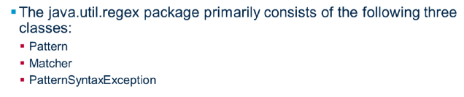
Q. 28 | Examples on pattern matching
Ans. | Example 1 :  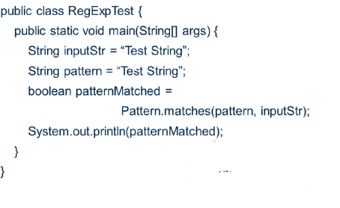  Example 2 :  import java.util.regex.*;  public class RegExpTest {  public static void main(String[] args)  {  String inputStr = "Test String";  String pattern = "Test String";  boolean patternMatched = Pattern.matches(pattern, inputStr);  System.out.println(patternMatched);  /*  * Pattern pattern1 = Pattern.compile(","); String[] str =  * pattern1.split("Shop,Mop,Hopping,Chopping"); for (String st : str) {  * System.out.println(st); }  */  String input = "Shop,Mop,Hopping,Chopping";  Pattern pattern1 = Pattern.compile("hop");  Matcher matcher = pattern1.matcher(input);  System.out.println(matcher.matches());  while (matcher.find())  {  System.out.println(matcher.group() + ": " + matcher.start() + ": "  + matcher.end());  }  }  }
 | Lesson 9:Exception Handling
Q. 29 | List ALL the Checked exception and UnChecked exception
Ans. | - Checked Exceptions : SQLException, IOException, ClassNotFoundException  - UnChecked Exceptions : NullPointerException, ArithmeticException, ArrayIndexOutOfBoundException, NumberFormatException
Q. 30 | Base class of all exception
Ans. | Throwable
Q. 31 | Define :  - Try  - Catch  - Finally  - Throw  - Throws
Ans. | 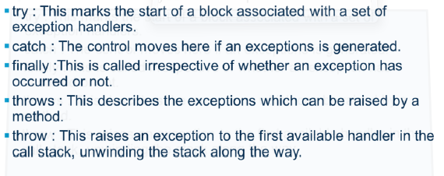
Q. 32 | Significance of Try-with-resource feature in exception handling
Ans. | A try-with-resources is a new feature added in java 7, where resources are closed automatically. Any block after try (either catch or finally block) will be executed only after the resource is closed
Q. 33 | Any null reference with method invocation will create NullPointer exception – Give example
Ans. | class TryCatchDemo{  public static void main(String a[]) {  String str= null;  try {  str.equals("Hello"); //NullPointerException  } catch(NullPointerExceptionne) {  str= new String("Hello");  System.out.println(str.equals("Hello"));  }  System.out.println("Continuing in the program");  }  }
Q. 34 | Layered architecture of Exception handling
Ans. | 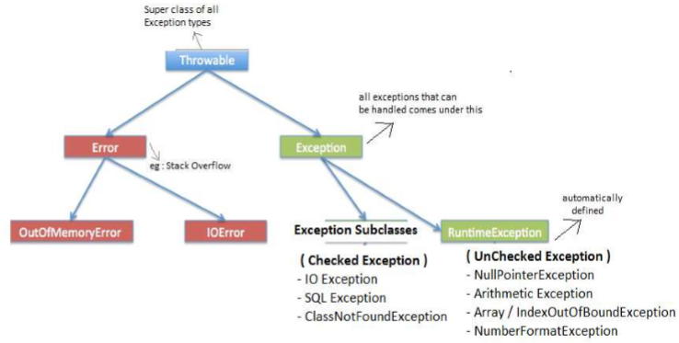
 | Lesson 10:Array
Q. 35 | Syntax for declaring and initializing arrays. Give example
Ans : | 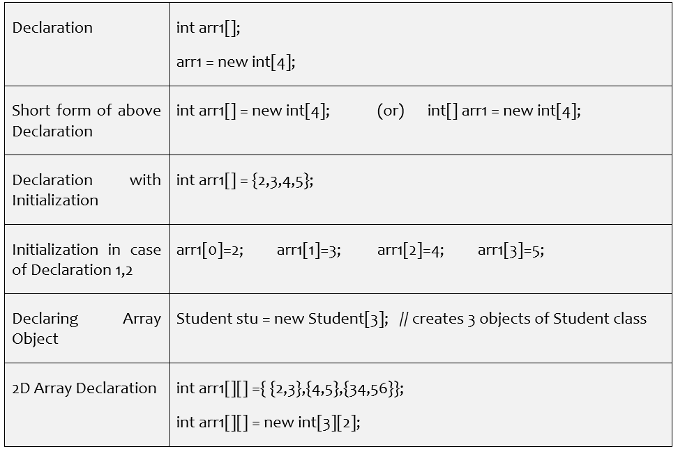
 | Lesson 11: Collection
Q. 36 | Difference between enhanced for loop and iterator with example.
Ans. | Iterator is an interface provided by collection framework to traverse a collection and for a sequential access of items in the collection. While enhanced For loop is meant for traversing items in a collection.  Example with iterator :  void printAll(Collection<Emp> employees) {  for (Iterator<Emp> iterator = employees.iterator(); iterator.hasNext(); )  System.out.println(iterator.next()); } }  Example of Enhanced for loop :
  void printAll(Collection<Emp> employees) {
  for (Emp empObj : employees) )
  System.out.println( empObj ); }}
Q. 37 | All collections’ comparison for ordered, sorted, duplicates, synchronization, key/value pair & allows null.
Ans. | 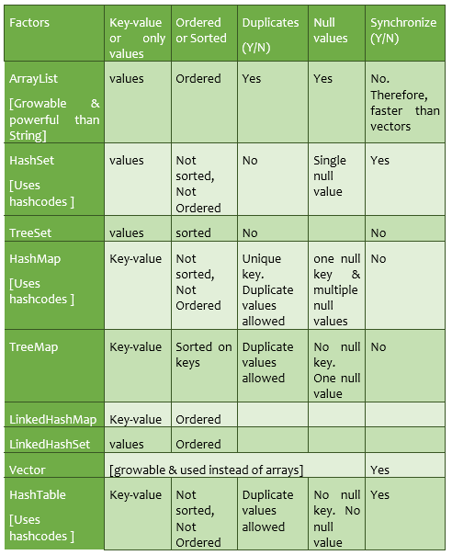
Q. 38 | Give an Example on :  - Arrays.sort(array)  - Collections.sort()  - remove()  - removeAll()  - isEmpty()
Ans. | - Arrays.sort():-  int[] arr = {13, 7, 6, 45, 21, 9, 101, 102};  Arrays.sort(arr);  - c) d) e)  ArrayList<String> al = new ArrayList<String>();  System.out.println("Initial size of al: " + al.size());  // add elements to the array list  al.add("C");  al.add("A");  al.add("E");  al.add("B");  al.add("D");  al.add("F");  al.add(1, "A2");  System.out.println("Size of al after deletions: " + al.size()); //7  al.remove("F");  System.out.println("Size of al after deletions: " + al.size()); //6  al.removeAll(); //remove all elements  System.out.println("al.isEmpty()); //returns TRUE
 | Lesson 12: File IO
Q. 39 | Different types of streams in File IO, Buffered Streams.
Ans. | 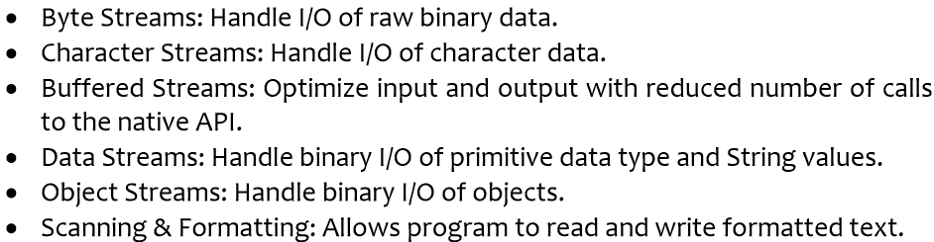
Q. 40 | Need of flush() & isFile() method with Examples.
Ans. | The java.io.Writer.flush() method flushes the stream. If the stream has saved any characters from the various write() methods in a buffer, write them immediately to their intended destination. Then, if that destination is another character or byte stream, flush it. Thus one flush() invocation will flush all the buffers in a chain of Writers and OutputStreams.  The java.io.File.isFile() checks whether the file denoted by this abstract pathname is a normal file.
Q. 41 | Difference between Serialization and Deserialization
Ans. | Serialization:  Serialization is the process through which we can store the state of an object into any storage medium. We can store the state of the object into a file, into a database table etc.  An object is serialized by writing it an ObjectOutputStream.  Deserialization:  Deserialization is the opposite process of serialization where we retrieve the object back from the storage medium.  An object is deserialized by reading it from an ObjectInputStream.
 | Lesson 13: Introduction to Junit 4 & Lesson 14: Advanced Testing
Q. 42 | Explain @Test with all attributes like timeout, expected.
Ans. | Example 1:  @Test(expected = ArithmeticException.class)  public void divideByZeroTest() {  calobj.divide(15,0);  }  Example 2:  @Test(timeout=1000)
Q. 43 | Explain methods of Assert class
Ans. | - Fail([String]) : It signals the failure of a test. This method has two formats. If the String argument is not provided, then no message is displayed. Else the String argument message is displayed.  - assertTrue(boolean) : It asserts if the condition is true. Similarly assertFalse(boolean) asserts if the condition is false.  - assertEquals([String message],expected,actual) : It asserts whether the two objects passed as arguments are equal. This method can accept any kind of values for comparison like double long, etc..  - assertNull([message],object) : It asserts that an object is null.  - assertNotNull([message],object) : It asserts that an object is not null.  - assertSame([String],expected,actual) : It asserts that two objects refer to the same object and assertNotSame([String],expected,actual) asserts that two objects do not refer to the same object.  - assertThat(String, T actual, Matcher <T> matcher) : It asserts that “actual” satisfies the condition specified by the “matcher”.
Q. 44 | Give Example : '@RunWith(Suite.class), @Suite.SuiteClasses
Ans. | import org.junit.runner.RunWith;  import org.junit.runners.Suite;  @RunWith(Suite.class)  @Suite.SuiteClasses({ TestCalAdd.class, TestCalSubtract.class,  TestCalMultiply.class, TestCalDivide.class })  public class CalSuite {  // the class remains completely empty,  // being used only as a holder for the above annotations  }
Q. 45 | Define :  @Before  @After  @BeforeClass  @AfterClass  @ignore
Ans. | - @Test – used to signify a method is a test method  - @Before – can do initialization task before each test run  - @After – cleanup task after each test is executed  - @BeforeClass – execute task before start of tests  - @AfterClass – execute cleanup task after all tests have completed  - @Ignore – to ignore the test method
Q. 46 | What is parameterized test?
Ans. | Allows you to run the same test with different data.  Syntax : @RunWith(Parameterized.class)

